**Green Campus Clean campus Cell**

****

**GREEN CAMPUS CLEAN CAMPUS CLUB REPORT 2019-2020**

|  |  |  |
| --- | --- | --- |
| Convener | Dr.Mujeeb Rahiman. K.M | C:\Users\user\Desktop\Mujeeb-Recenet Photo.jpg |
| Joint Convener | Smt. Asha Neendur | C:\Users\user\Desktop\Asha miss-Photo.jpg |
| Student Co-Ordinator | Beegam Faseela. P | **D:\BD  & GCCC Club\GCC BD\IMG_4196.JPG** |

**11. 7.2019: Cleaning of the ladies hostel path way**

**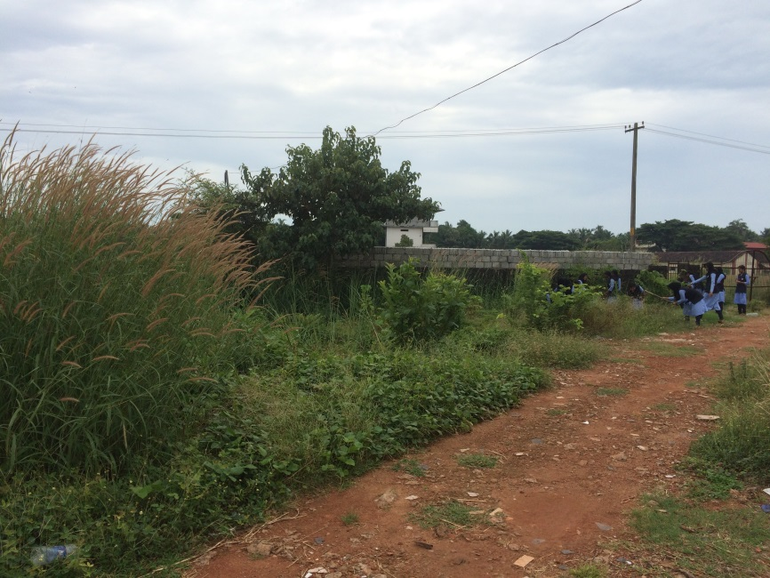**

**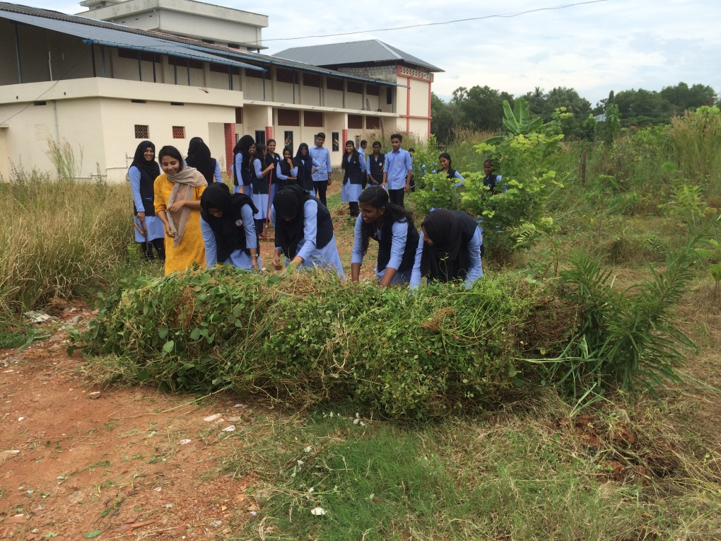**

**5.8.2019: Planting 10 clock plants and anar plants in front of the college campus**

**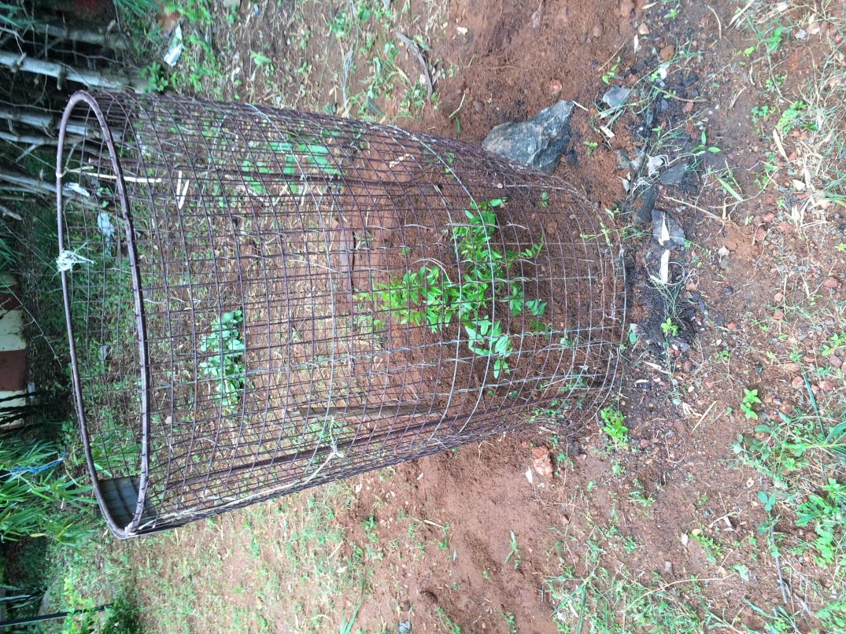**

**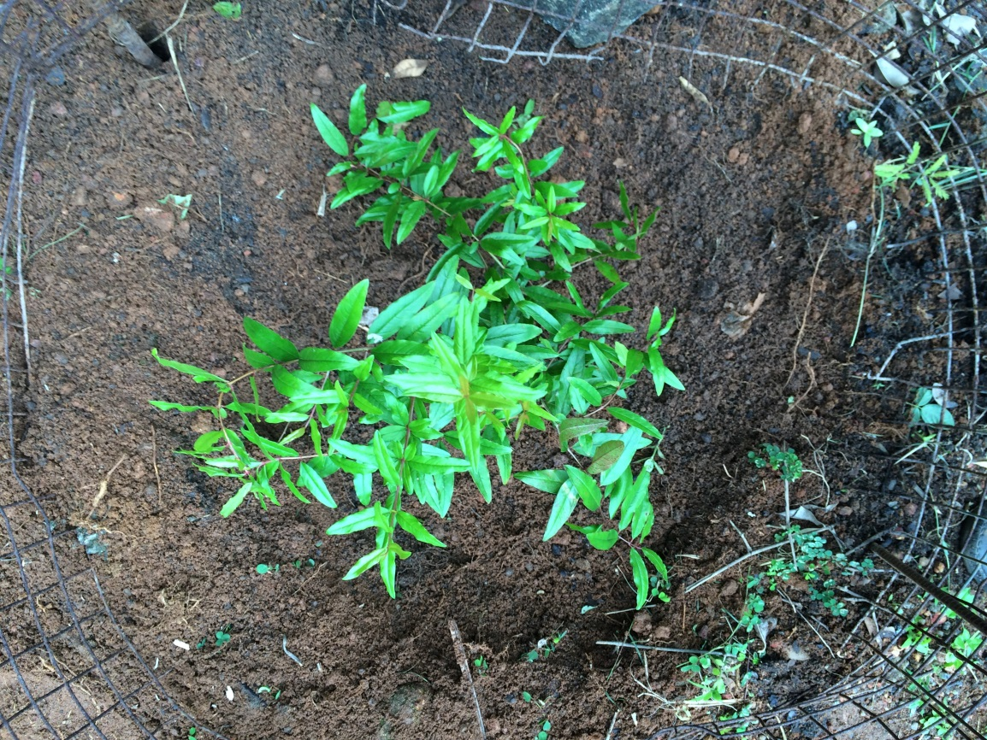**

**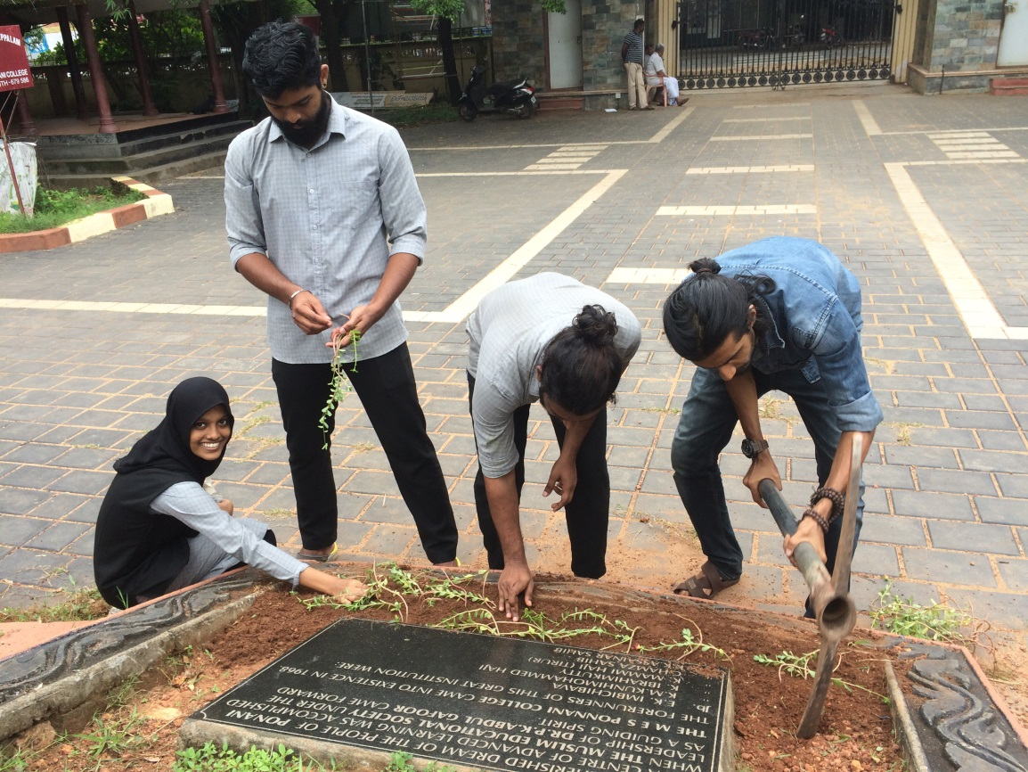**

**25. 9.2019: beautification work in progress with new flowering plants**

**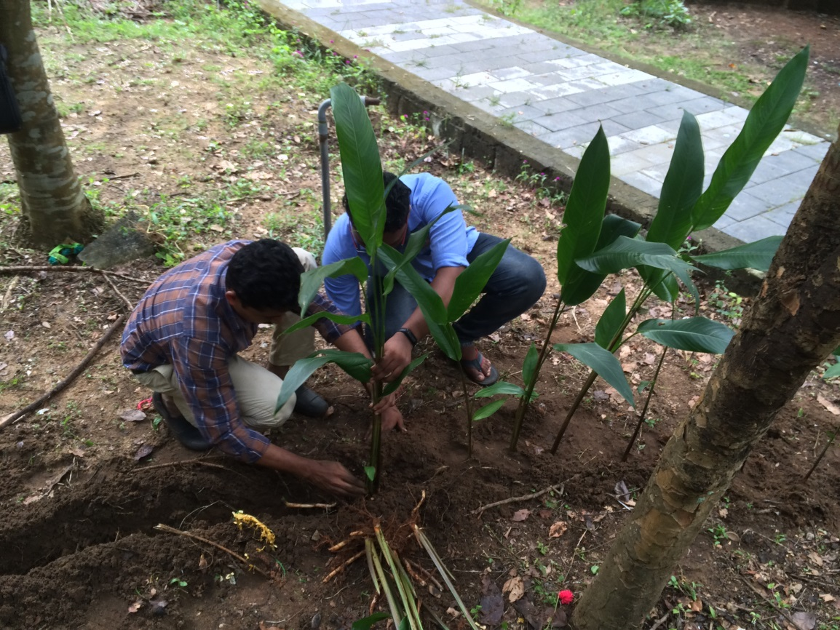**

**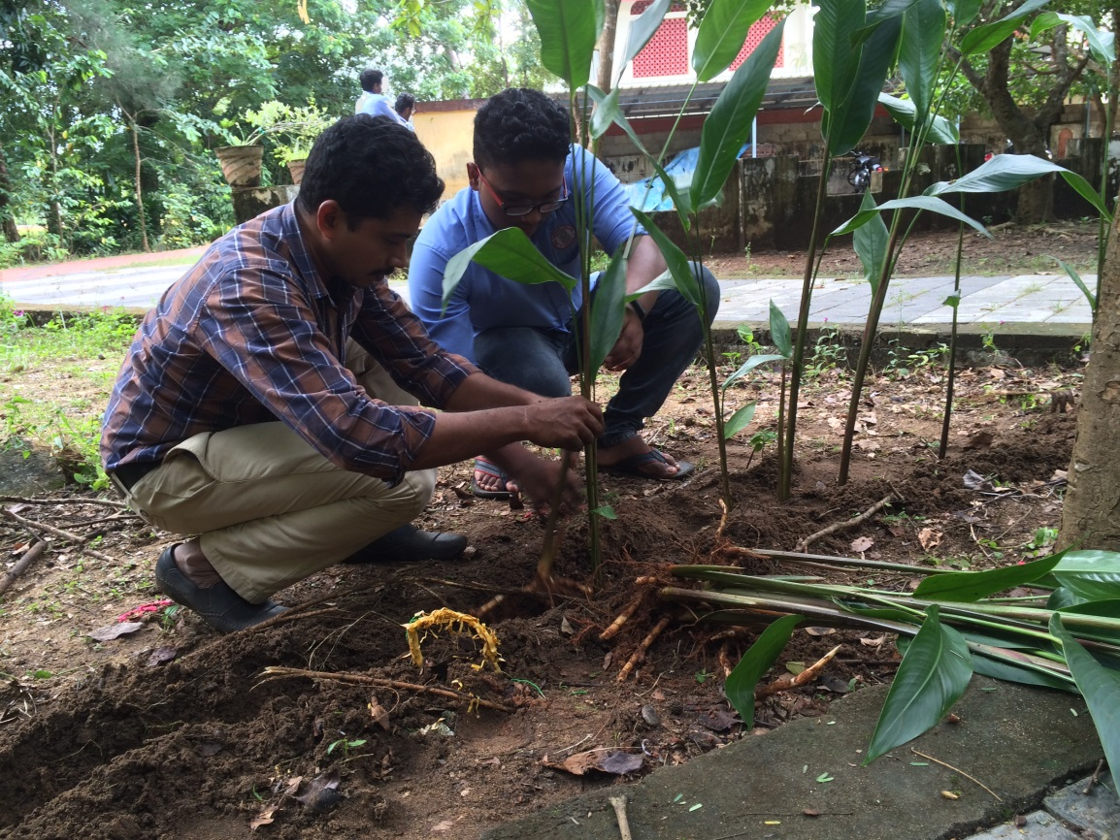**

**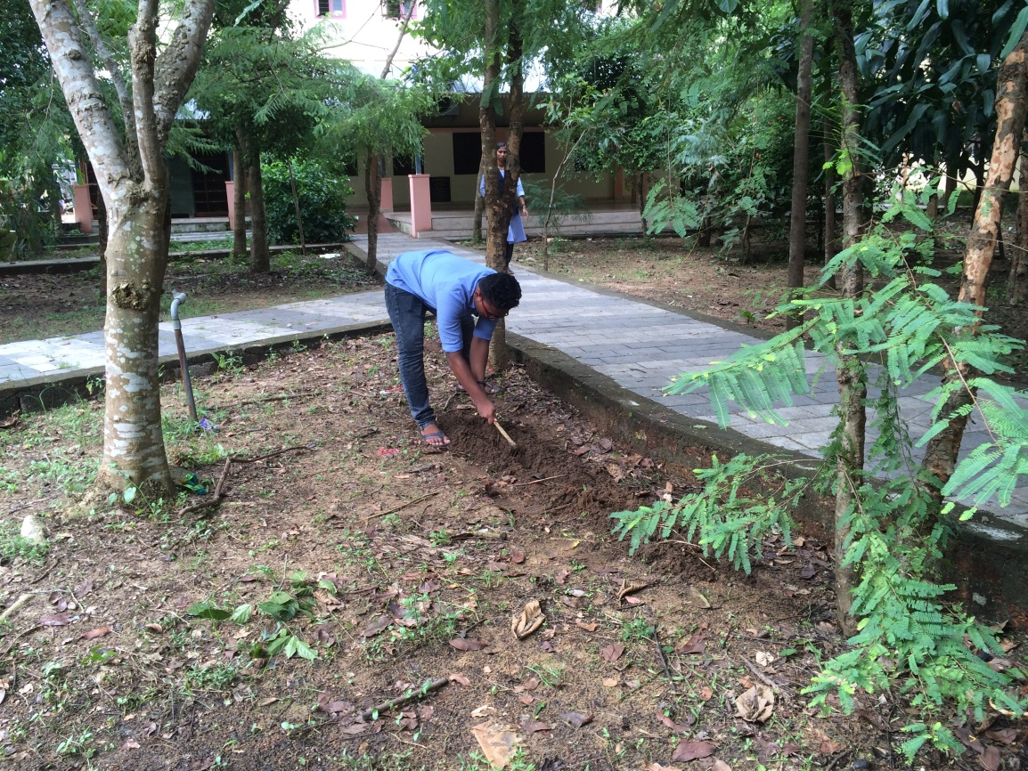**

**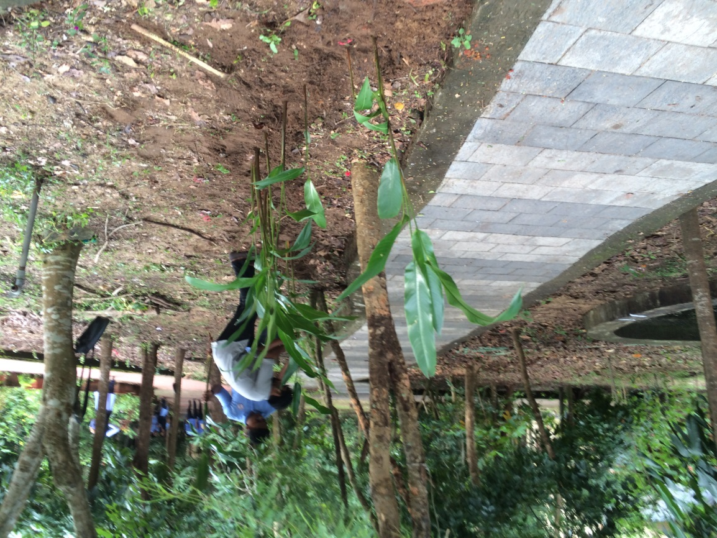**

**17. 10.2019: Cleaning and beautification of the college premises**

**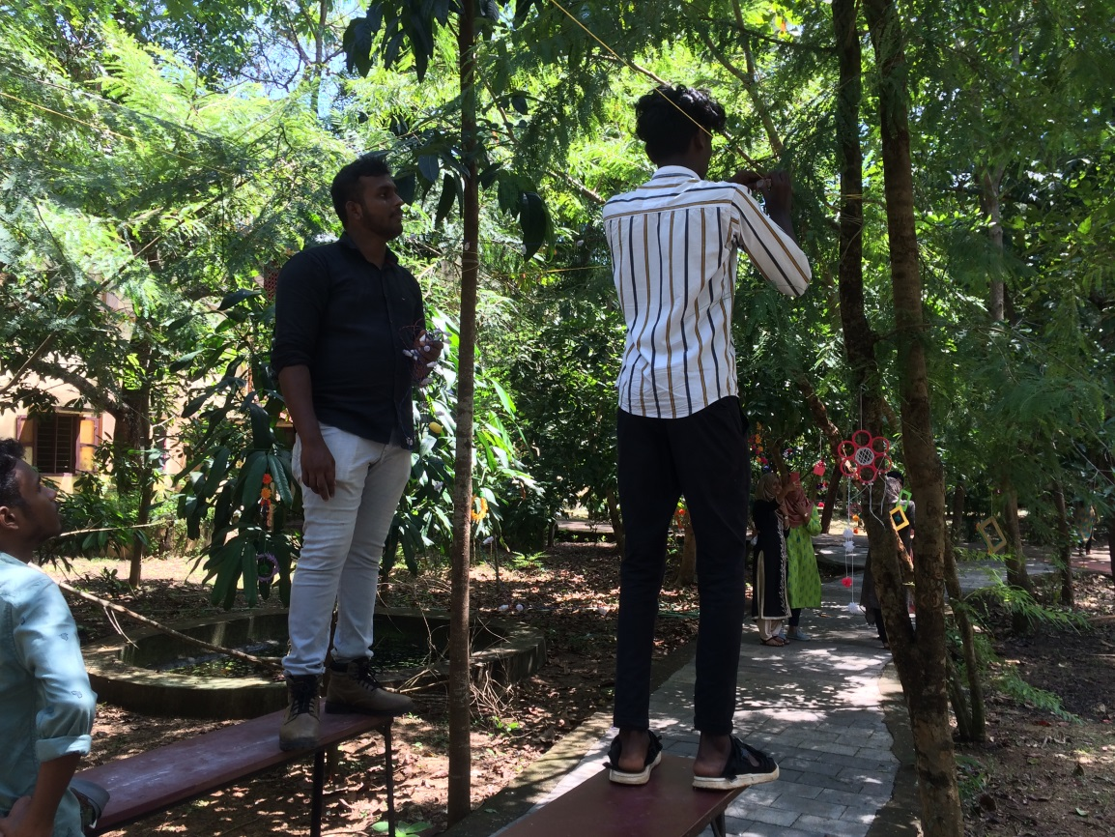**

**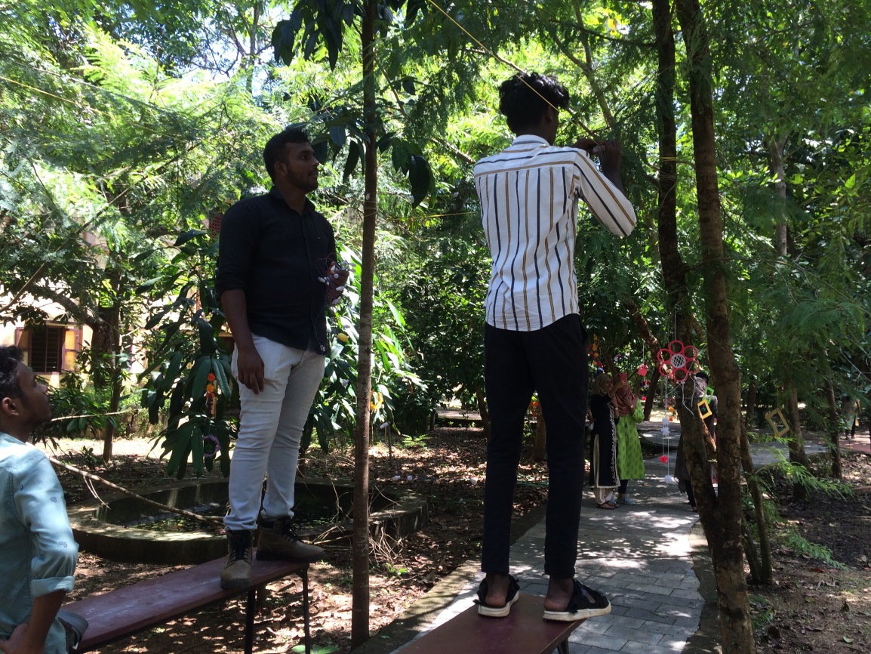**

**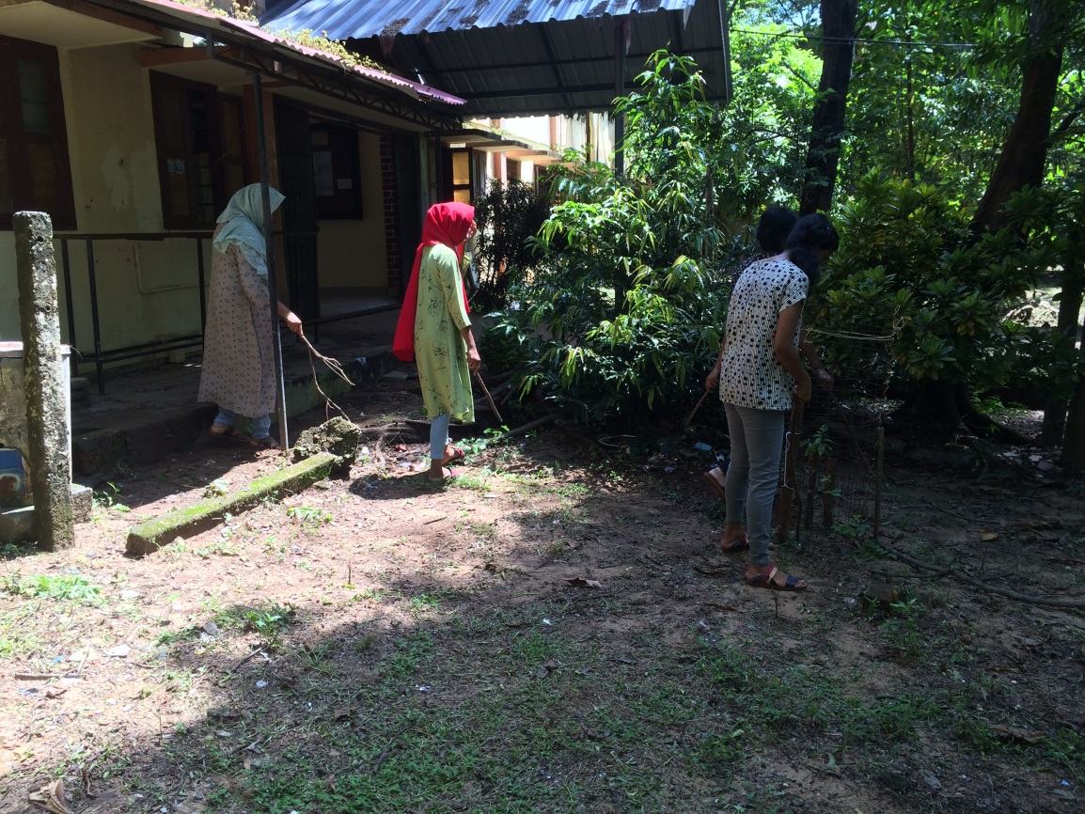**

**8. 1.2020: Added new flowering plants in the college front garden**

**